#ниже местами от 1 лица, местами от третьего, т.к. начало из одного ответа, а далее - из другого. Как писать - на ваше усмотрение, правила четкого нет.

Case No. ________________
accepted for review on _____________
Beneficiary: Mr. _____________

Area: ____________
Specialization: ________________
Dear USCIS Director!

My name is ________________.
Thank you for the given chance to convince you that I meet the criteria set out in 8 CFR section 204.5(h) (3).
Additional evidence and explanations are provided below in response to the questions set out in the Request for Evidence dated _______________.

I have written the petition and provided evidence that I satisfy seven (i, ii, iii, iv, v vi, viii) of ten criteria listed in 8 CFR section 204.5(h) (3), namely:

(i) Evidence of Mr. __SURNAME__’s receipt of nationally or internationally recognized prizes or awards for excellence
(ii) Evidence of Mr. __SURNAME__’s membership in associations in the field which demand outstanding achievement of their members
(iii) Evidence of published material about Ms. __SURNAME__ in professional or major trade publications or other major media.
(iv) Evidence of Mr. __SURNAME__’s participation, either individually or on a panel, as a judge of the work of others, in the same or an allied field.
(v) Evidence of Mr. __SURNAME__’s original scientific and business-related contributions of major significance to the field.
(vi) Evidence of Mr. __SURNAME__’s authorship of scholarly articles in the field, in professional or major trade publications, or other major media
(viii) Evidence of Mr. __SURNAME__’s performance of a leading or critical role in distinguished organizations.

In accordance with the Request for Evidence (hereinafter referred to as RFE) dated XXXXX XX, 20XX, during the consideration of my petition, the compliance with two of the listed criteria has been met:
(iv) Evidence of judging the work of others, either individually or on a panel.
(vi) Evidence of Ms. __SURNAME__’s authorship of scholarly articles in the field, in professional or major trade publications, or other major media
In RFE you asked additional questions and I was instructed to provide additional documents and explanations.
In this response I have tried to provide additional evidence of compliance with the mentioned criteria and additional explanations in response to the questions formulated in the RFE and that I have an extraordinary ability in XXXX, especially in XXXXXXXXXXXXXXX

Please, be informed that I’ve structured the information in this response as follows:
- I give explanations, additional details and evidence concerning several general matters and doubts expressed in the RFE - page XX;
- I offer more details and information concerning my intent to continue my professional activities in the field of XXXX, XXXX in USA - page XX;
- I provide explanations and additional evidence regarding the list of remaining criteria claimed in my application - pageXX.
In addition to additional evidence, this response contains some evidence previously attached to the petition, for your convenience. At the same time, other voluminous evidence previously attached to the petition is not provided again, but is mentioned as part of the response.

Thank you.
Sincerely,
NAME __SURNAME__
December XX, 20XX

Continued Work
As it follows from the RFE,
- “You did not submit evidence of prearranged commitments. While you submitted a statement, it lacked detailed plans establishing how you will continue your work in your profession. Statements only expressing your prospective hopes of finding work or offering vague ambitions do not constitute detailed plans or the type of clear evidence that demonstrates eligibility under 8 C.F.R. 204.5(h)(5).
- In summation, there are insufficient facts demonstrating how you will continue to work and that you have the means to accomplish your plans. Therefore, please submit supporting evidence that you are coming to the United States to continue working in the field in which you claim to have garnered sustained national or international acclaim. Evidence that may be submitted to satisfy this requirement includes, but is not limited to:
  - Letters from current or prospective employers;
  - Employment contracts;
  - Client contracts
  - Your U.S. state business license (issued prior to the filing of your 1-140)
  - eLeases
  - Business loan information”
In response to these remarks, please, find the additional evidence as follows:
txt….

(ii) Evidence of Mr. ___SURNAME_____'s membership in associations in the field which demand outstanding achievements of their members

As it follows from the RFE, this criterion has not been met because:
- While this organization requires professional achievements of its members and requires members to be nominated by other members, association bylaws do not state they require outstanding achievements or use recognized national or international experts to determine which individuals qualify for membership. Evidence must demonstrate that the association requires outstanding achievement as an essential condition for admission to membership.

We provide you with additional evidence and explanations concerning that the associations mentioned in the petition require outstanding achievements or use recognized national or international experts.

- Association’s title
As
text
1) Association by-laws require outstanding achievements to determine which individuals qualify for membership.
- text

Thus, Mr. ___SURNAME_____ was accepted for his outstanding achievements: His renown as an exceptional specialist and for his contribution to the development of the export of Russia's agro-industrial complex. The requirements for outstanding achievements are stipulated in the Association's Membership Regulations.
2) The decision to admit Mr. ___SURNAME_____ as a member of the association was made by national-level experts.
- text
Accordingly, the decision to admit members was made by prominent national-level experts.

Thus, Mr. ____NAME_____SURNAME_____ is a member of three major and respected associations in his field of activity, which require outstanding abilities and achievements to join.
The by-laws of these associations stipulate the requirement for outstanding achievements for admission to the association.

(iii) Published material about Mr. ___SURNAME_____ in professional or major trade publications or other major media. The materials must relate of the petitioner's work in the field for which classification is sought.

As it follows from the RFE, this criterion has not been met because:
- The petitioner did not submit sufficient evidence to establish the circulation statistics for the publications, neither did the petitioner provide other circulation data to compare with those of this website, or information about its intended audience.
- Without additional corroboration, the petitioner has not illustrated that the online material was professional or major trade publications or other major media.

We provide you with additional evidence and explanations concerning the articles specified in the petition that establish the circulation statistics for the publications and show in a comparison that the online material was professional or major trade publications or other major media.
*Additional evidence is marked with the phrase “New evidence” for convenience. Also, for the convenience of presentation, a part of the evidence that has already been presented in the framework of the petition is given. The description of this evidence does not contain the label “New evidence”.

1) Mr. ___SURNAME_____ provided evidence about the interview published about him in the Komsomolskaya Pravda newspaper titled "____NAME_____SURNAME_____ revealed the secrets of the "XXXXXX" that was published on XXXX XX, 20XX.
- Documentary evidence that the material has been published.
Mr. ___SURNAME_____ provided the following documents:
- Text of the article in Komsomolskaya Pravda, its translation to English (Exhibit XX of the petition, page XX);
- explanatory note about "Komsomolskaya Pravda" newspaper (Exhibit XX of the petition, page XX).

Here is the brief information about the article:
• The title, date, and author of the published material
The title of the article: "____NAME_____SURNAME_____ revealed the secrets of the "Sweet business"
Permanent address on the Internet: __________
Publication date: XXXXXX XX, 20XX.
Author: XXXXXXXX, professional Journalist.
If the link is inaccessible - it may be because of the current political situation, so please refer to the screenshots of the publication provided in the Exhibit XX, page XXXX Text of the publication in Komsomolskaya Pravda about Mr. ___SURNAME_____ and its translation into English.
The publication is written about Mr. ___SURNAME_____ and his work in the field, which clearly follows from the screenshots and its translation. Please refer to the excerpts from the screenshots below. If necessary, please kindly refer to Exhibit XX, page XXXXX to this answer - Text of the publication in Komsomolskaya Pravda about Mr. ___SURNAME_____ and its translation into English.
Mr. ____NAME_____SURNAME_____, being an expert in the field of sales and marketing, and in particular in the field of confectionery business, shared his opinion about the complexity of working in the confectionery market, and also told about his work – about what he did during his work at THE COMPANY, how he built business processes what he changed and what decisions he considers important. The journalist was also interested in what management decisions of Mr. ____NAME_____SURNAME_____ led the company to success and how he sees his personal contribution to the development of the company.
Evidence that the publication was about Mr. ___SURNAME_____ and his work was provided as part of the petition, and this fact raised no objections.

We provide additional evidence that the online publication "Komsomolskaya Pravda" is a major media outlet:

The circulation (online and/or in print) and The intended audience of the publication.
NEW EVIDENCE
- Komsomolskaya Pravda has a vast weekly audience of 45.3 million people. Komsomolskaya Pravda is popular throughout Russia and in the CIS countries. It follows from the mediakit of the publication:
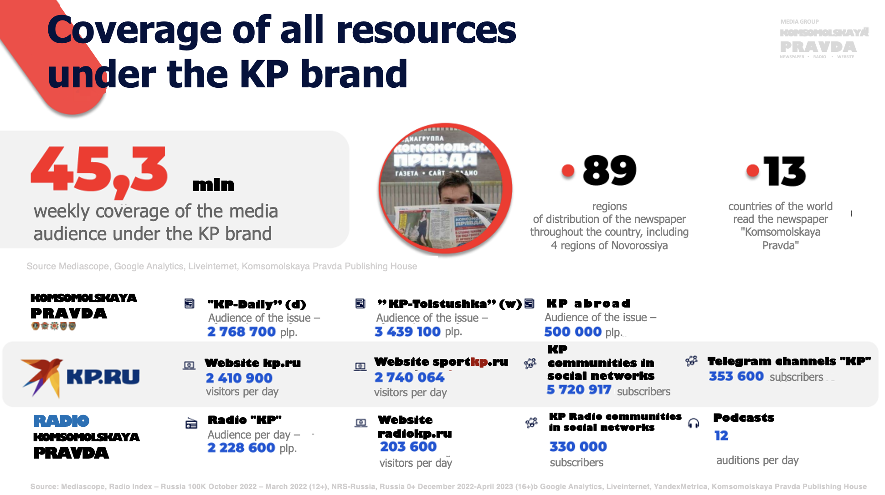
(Please, kindly refer to Exhibit XX, page XX mediakit of Komsomolskaya Pravda and its translation into English.)

As can be seen from the excerpt from the media kit provided above, the online publication has 2,410,900 readers per day. Moreover, the online edition is an integral part of the "Komsomolskaya Pravda" brand.
It's worth noting separately that the online edition is registered as a media outlet by the state regulatory body for information oversight - Roskomnadzor. Certificate EL № FS77-80505 dated March 15, 2021

Here are the screenshot:
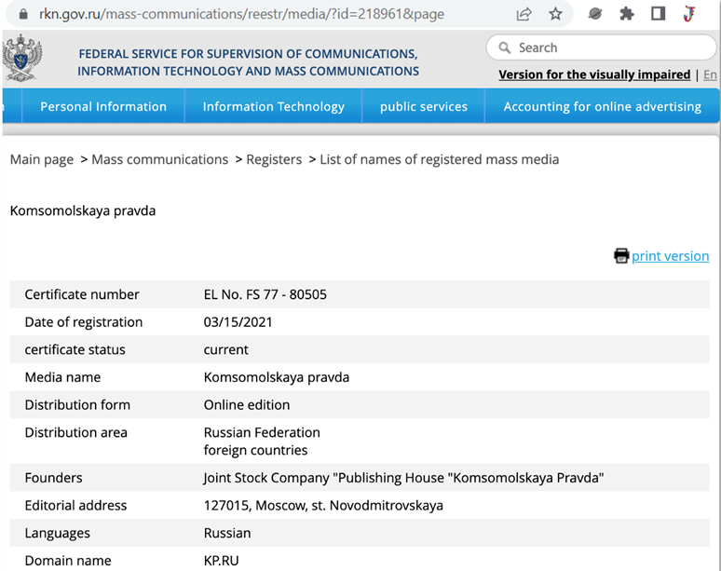
Source: rkn.gov.ru/mass-communications/reestr/media/?id=218961&page
Information about the registration of the Online Publication "Komsomolskaya Pravda", as well as other details about the media, are also provided in the explanatory note: (Please, kindly refer to Exhibit XX, page XX, Explanatory note about "Komsomolskaya Pravda").
NEW EVIDENCE
- Komsomolskaya Pravda regularly ranks at the top in ratings, proving that Komsomolskaya Pravda is the leading online media outlet in Russia:
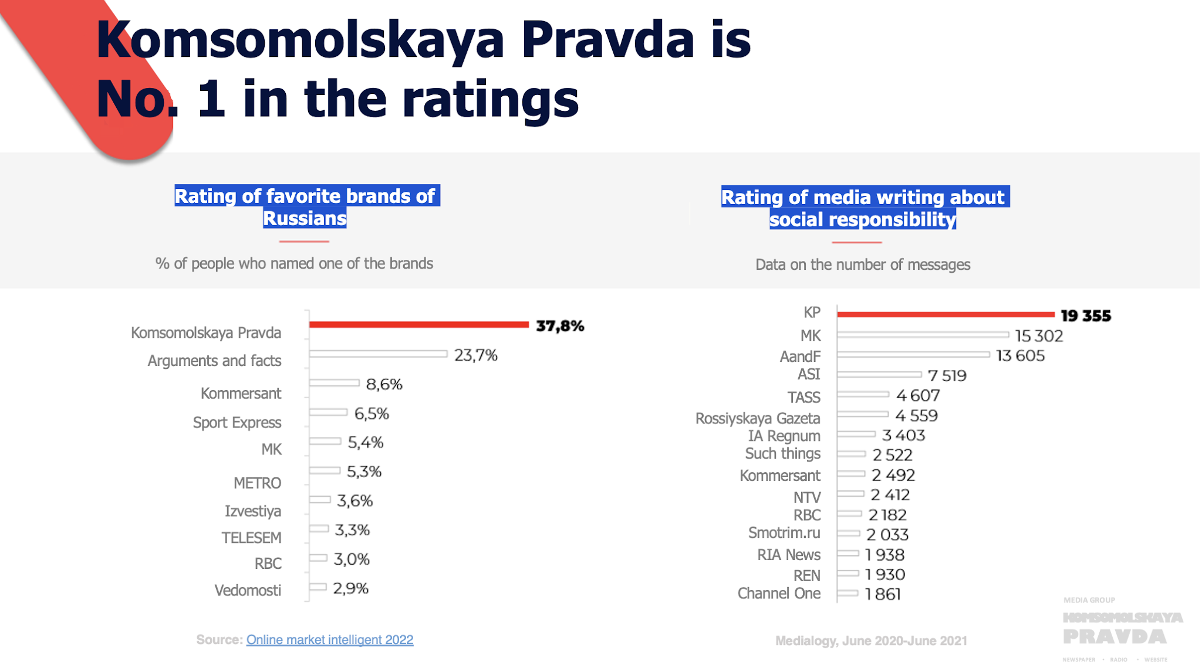
(Please, kindly refer to Exhibit 20, page 362 mediakit of Komsomolskaya Pravda and its translation into English.)

- Some important information about Komsomolskaya Pravda as the largest online media in Russia:
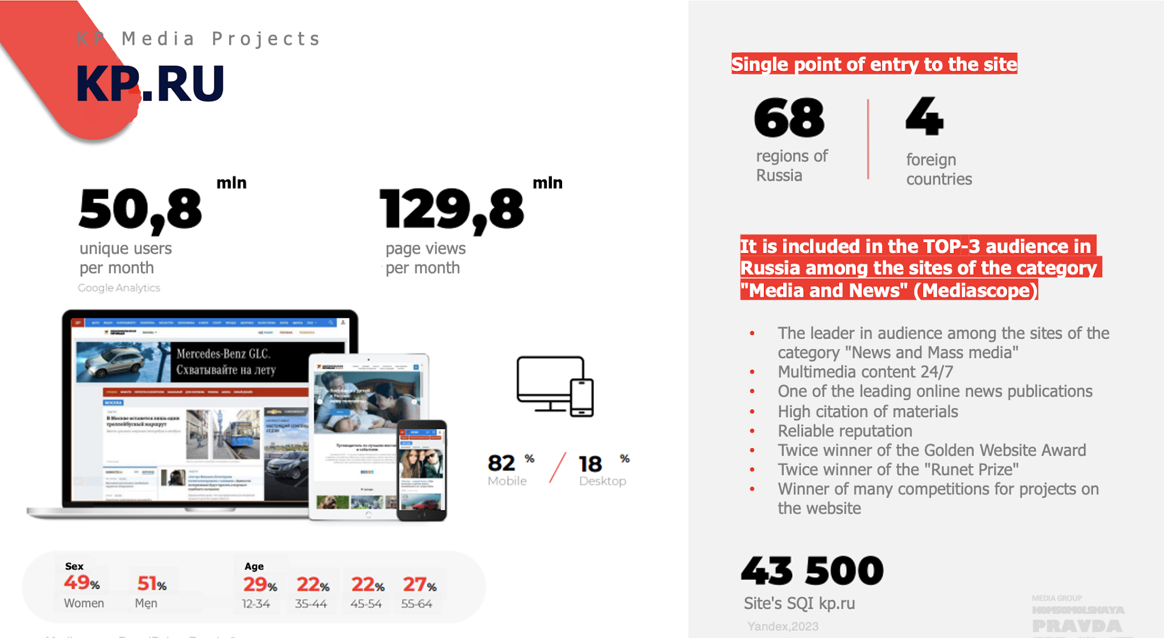
(Please, kindly refer to Exhibit 20, page 362 mediakit of Komsomolskaya Pravda and its translation into English.)
Every month, the online publication "Komsomolskaya Pravda" is visited by 50.8 million unique users. According to the analytical service "Mediascope," the online edition of "Komsomolskaya Pravda" consistently ranks in the top 3 in audience size in Russia in the Media and News category.
Additionally, Mediascope notes the reliable reputation of the "Komsomolskaya Pravda" publication, the high citation rate of its materials, and the presence of numerous awards.
The original Media Kit of "Komsomolskaya Pravda" and its translation are attached to this response (Please, kindly refer to Exhibit 20, page 362 mediakit of Komsomolskaya Pravda and its translation into English.).
NEW EVIDENCE
- Statistics of visits to the Komsomolskaya Pravda online publication in comparison with popular online media “USAToday.com .”
According to the service Similarweb.com , the number of visits to this media outlet per month is 77.5 million unique users, of which 82.51% are visits from Russia. This is 44.2% of the population of Russia, which is 144.4 million people according to https://www.worldometers.info
For comparison, the number of large online media Usatoday.com It is 146.4 million users, of which 121.8 million are visits from the United States. In turn, this is 35.8% of the US population.
Usatoday.com - one of the largest media outlets in the USA.
Accordingly, in proportion to the number of the population, Komsomolskaya Pravda surpasses the American online media in attendance “USAToday.com .”
This clearly demonstrates that Komsomolskaya Pravda is one of the largest mass media in Russia.
Below is a table for a visual comparison.
Population of the USA (340.2 mln); Link: https://www.worldometers.info/world-population/us-population/
 | Usatoday.com total visits | Visits from the USA, % | Visits from the USA (mln) | % of the USA population
Usatoday.com | 146.4 mln | 83.22% | 121.8 mln | 35.8%

Population of Russia (144.4 mln); Link: https://www.worldometers.info/world-population/russia-population/
 | Total visits | Visits from Russia, % | Visits from Russia (mln) | % of the Russia population
kp.ru | 77.5 mln | 82.51% | 63.95 mln | 44.2%
Rosbalt.ru | 4.1 mln | 82.31% | 3.37 mln | 2.33%
SM.News.ru | 6.5 mln | 89.96% | 5.85 mln | 4.05%
Pradva.ru | 13.9 mln | 69.16% | 9.61 mln | 6.65%
RBC | 14 mln | 100% | 14 mln | 9.6%
The comprehensive visit statistics for "Komsomolskaya Pravda" and the media outlet "USAToday.com", the source of statistics with screenshots as well as their comparison, are provided in the corresponding exhibit (Please, kindly refer to Exhibit 22, page 374, Statistics of Russian media in comparison to the US media and explanatory note about US media)
- Awards.
At the same time, Komsomolskaya pravda is subject to the huge number of awards such as International award Eventiada IPRA GWA 2021 in the nomination " Best Project in Support of Building Resilient Infrastructure, Promoting Inclusive and Sustainable Industrialization and Innovation"
Source: https://www.kommersant.ru/doc/5117231
and it was the winner of the Runet award in 2020. It is given for contribution to the development of the Russian segment of the Internet (Runet).
Source: https://www.kp.ru/daily/21712095/4332309
and the winner of the open all-Russian Internet contest "Golden website".
Source: https://old.goldensite.ru/ViewAllWinners2012.aspx
Journalists of IA "Komsomolskaya Pravda" became winners of the professional competition "My earth – Russia".
Source: https://www.kp.ru/daily/28362/4511185

For the full list of evidence with screenshots and commentaries please kindly refer to Exhibit 21, page 368 Explanatory note about Komsomolskaya Pravda.)
- Rankings.
NEW EVIDENCE
We present the data from the Infoselection.ru service. In it, Komsomolskaya Pravda occupies the second spot in the ranking of the top 100 media outlets in Russia.
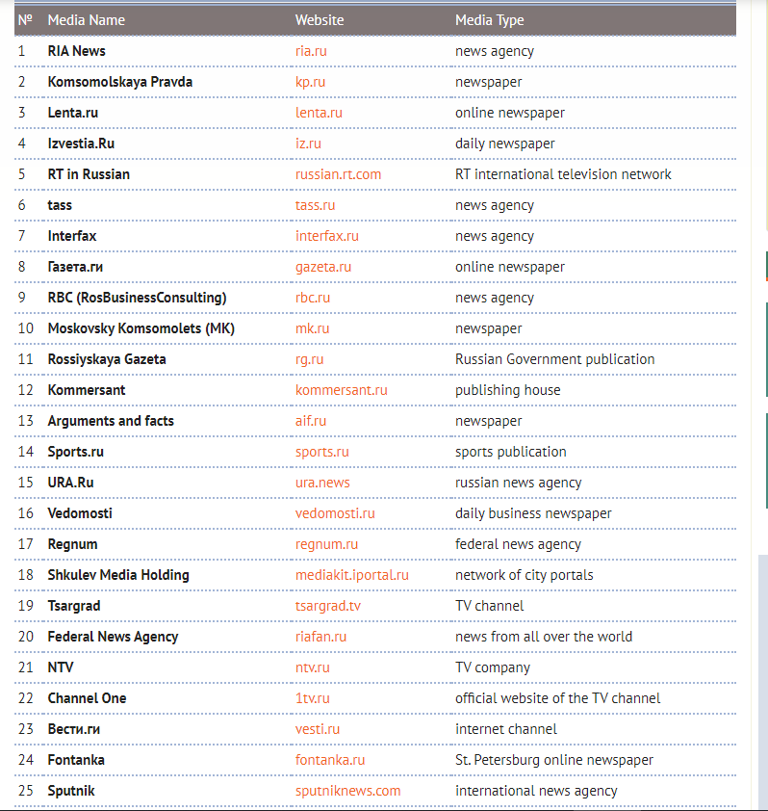
Source: https://infoselection.ru/infokatalog/novosti-smi/smi/item/249-20-samykh-poseshchaemykh-novostnykh-resursov-runeta
Komsomolskaya Pravda also occupies the second spot in the ranking of the most popular online media in a separate ranking dedicated to Online Publications.
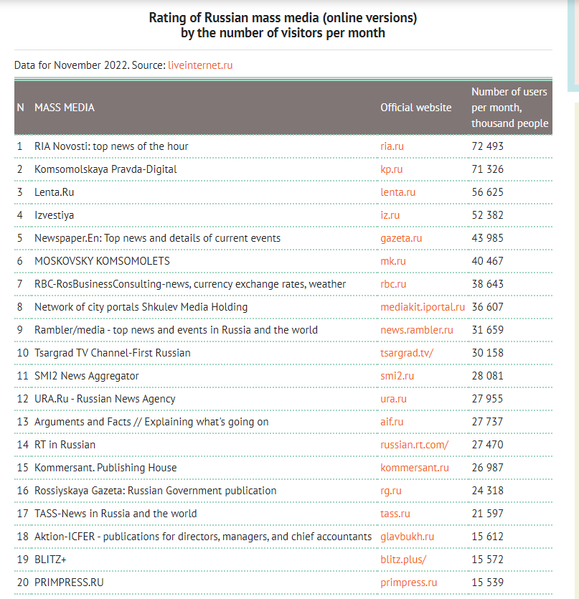
Source: https://infoselection.ru/infokatalog/novosti-smi/smi/item/249-20-samykh-poseshchaemykh-novostnykh-resursov-runeta
The ranking includes the 150 largest online media outlets in Russia.
We separately provide the full original version of the ranking and its translation in the exhibit (Please, kindly refer to Exhibit XX, page XX, Infoselection.ru rankings of major Russian media, its translation into English, explanatory note about infoselection.ru service).
NEW EVIDENCE
Additionally, we also present the ranking of online media in Russia according to the Liveinternet.ru service. In it, Komsomolskaya Pravda occupies the top spot, making it the most popular online media in Russia.
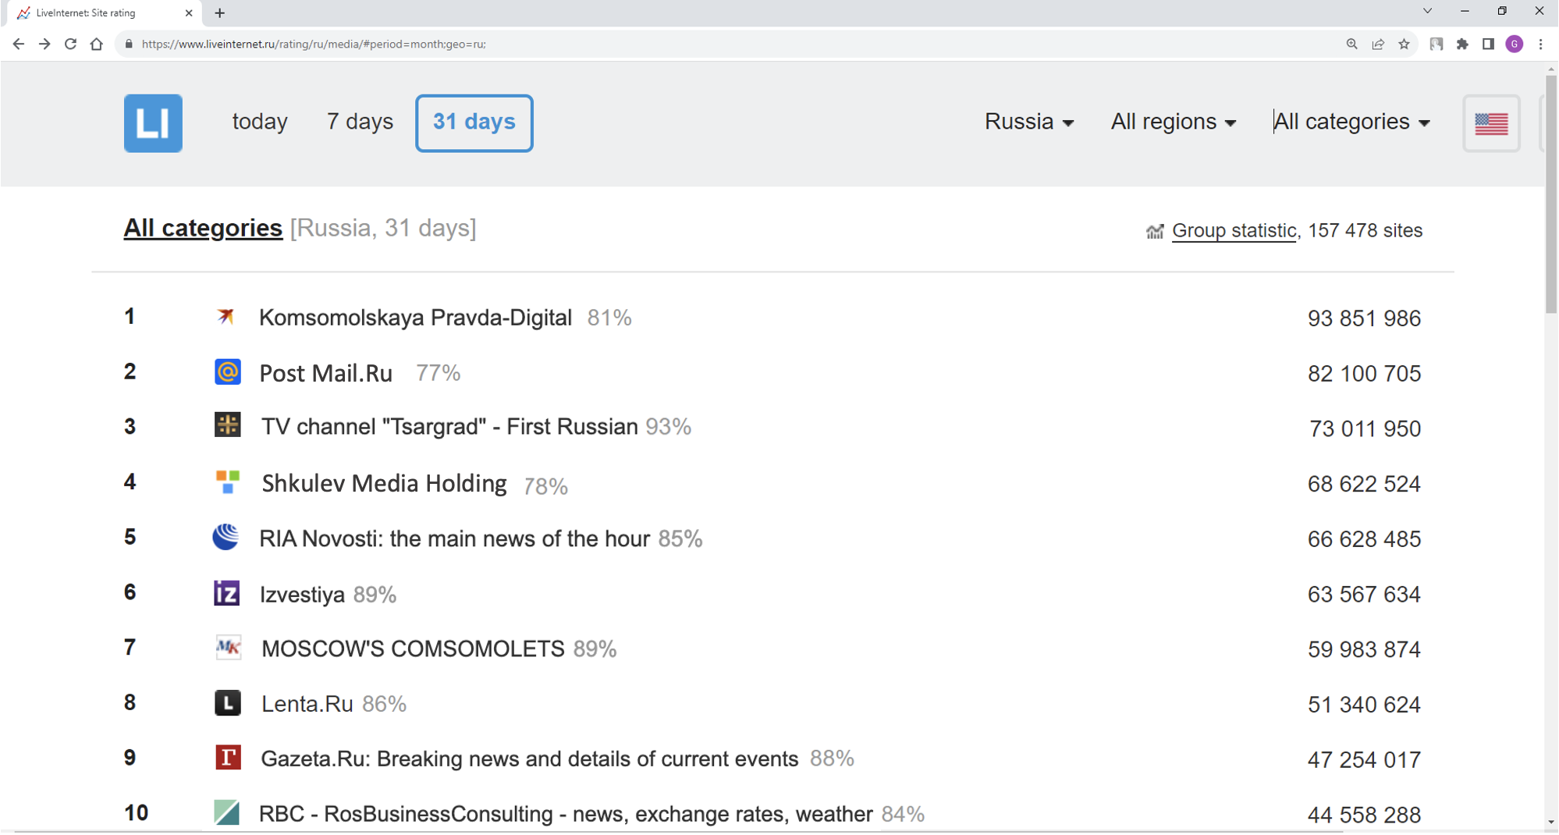
Source: https://www.liveinternet.ru/rating/ru/media/#period=month;geo=ru;group=media
We separately provide the full original version of the ranking and its translation in the exhibit (Please, kindly refer to Exhibit XX, page XX, Liveinternet.ru ranking of major Russian media, its translation into English, explanatory note about liveinternet.ru service).

Thus, "Komsomolskaya Pravda," and especially its online version, undoubtedly occupies the top spots in the rankings of the most popular media outlets in Russia, both in terms of visitation and citation volumes, making it the largest media outlet in Russia.

Thus, it is safe to conclude that Komsomolskaya Pravda is one of the largest Russian media, whose audience is the whole of Russia, and which regularly leads in media ratings both in terms of attendance and citation. The credibility of the media is confirmed by many awards.

(viii) Evidence that Mr. ___SURNAME_____ has performed in a Leading or critical role for organizations or establishments that have a distinguished reputation.
As it follows from the text of RFE, This criterion has not been met because:
- the petitioner must provide a basis for comparison to show that THE COMPANY, is distinguished in relation to other companies in the same industry.
In this regard, Mr. ___SURNAME_____ provides additional evidence, as well as explanations, from which it follows that ___THE COMPANY___, is distinguished in relation to other companies in the same industry:
*Additional evidence is marked with the phrase “New evidence” for convenience. Also, for the convenience of presentation, a part of the evidence that has already been presented in the framework of the petition is given. The description of these evidences does not contain the label “New evidence”.
- Evidence documenting the organizations' eminence, distinction, or excellence from which it is apparent that the THE COMPANY Company has distinguished reputation:
NEW EVIDENCE
- THE COMPANY ranks among the top 50 confectionery companies in Russia by sales value. Considering the fact that there are over 1000 confectionery factories operating in Russia, the Confectionery Factory THE COMPANY is in the top 5% in its industry.
As follows from the tax return of the THE COMPANY company for 2021, the company's income from sales of products for 2021 amounted to 891,657,354 rubles. Thus, THE COMPANY is a national-scale company with large turnover.

(Please, kindly refer to exhibit XX, page XX, the tax declaration of the company “THE COMPANY” on income tax for 2021, its translation into English).
NEW EVIDENCE
The THE COMPANY company is included in the rating of the largest confectionery companies in Russia in terms of revenue, which certainly characterizes the company as a large company with a high reputation in the market.
X
X
(Please, kindly refer to Exhibit xx page xxx Ranking of Russian manufacturers of flour confectionery products in terms of revenue for 2021, its translation into English, Explanatory note).
It should be noted that only 134 companies were included in the rating, at the same time, according to the wikiprom.ru website, there are more than 1,000 confectionery companies operate in Russia:

(Please, kindly refer to Exhibit xx, page xx Ranking of Russian manufacturers of flour confectionery products in terms of revenue for 2021, its translation into English, Explanatory note).
Thus, THE COMPANY is one of the 5% of the largest confectionery companies in terms of revenue in Russia, which makes the company's reputation indisputable.

- THE COMPANY Company is the recipient of prestigious awards for excellence in the field of confectionery business.
As part of the petition, evidence was presented that the THE COMPANY company, thanks to the activities of Mr. ___SURNAME_____, received the most prestigious major international awards at the PRODEXPO food exhibition:
2.1. Waffle products of THE COMPANY Company with THE COMPANYFF trademark earned a gold medal at the prestigious "Best Product" competition in 2020 held during the 27th International Exhibition of Food, Beverages, and Raw Materials for their Production, known as PRODEXPO 2020.
2.2. Waffle products with the THE COMPANY trademark won a bronze medal at the same event.

xx
And the translation of the diplomas:

xx
And the second:

x
(Please, kindly refer to Exhibit x, page x Diplomas from PRODEXPO 2020 photo of medals, its translation into English, explanatory note about PRODEXPO).
NEW EVIDENCE
The largest specialized media (dedicated to business in the field of retail and food products) wrote about the competition:

xx
Link: ___
(Please, kindly refer to Exhibit 72, page xx Publications about the PRODEXPO exhibition, their translation into English).
PRODEXPO is an exhibition of food products on a global scale. We provide information about the exhibition:
The Prodexpo-2020 exhibition demonstrated growth in all statistical indicators. The best samples of food and beverages were presented by 2,664 companies from 73 countries of the world. This is 247 more companies compared to last year. The participants of the exhibition on a total area of more than 100 thousand square meters presented all segments of the Russian and foreign food market without exception. 31 countries were represented by national expositions: Azerbaijan, Argentina, Armenia, Belgium, Brazil, China, Cuba, Greece, Hungary, India, Indonesia, Spain, Italy, Poland, Portugal, Republic of Korea, Republic of Moldova, Republic of South Ossetia, North Macedonia, Serbia, Tajikistan, Thailand, Turkey, Uzbekistan, Uruguay, Philippines, France, Croatia, Chile, Sri Lanka, South Africa. The premiere of this year was the national exposition of the Philippines. For the first time, companies from Venezuela and Uganda took part in the exhibition. The exhibition attracted a large number of visitors, the number of which amounted to 69,730 people from 115 countries, including representatives of 85 subjects of the Russian Federation from 1,273 localities. These high indicators indicate that Prodexpo continues to be the main platform of the food industry, where Russian enterprises meet with a wide range of partners and buyers. 1,853 domestic manufacturers and suppliers of food and beverages took part in the exhibition, which is 165 companies higher than last year. Collective stands of Russian regions have doubled their presence. Regional collective expositions united companies from 47 subjects of the Russian Federation.

At the official opening ceremony of the exhibition, participants and guests were welcomed by Chairman of the State Duma Committee on Regional Policy and Problems of the North and Far East Nikolay Kharitonov, First Deputy Chairman of the Federation Council Committee on Agrarian and Food Policy and Environmental Management Sergey Lisovsky, Deputy of the State Duma of the Federal Assembly of the Russian Federation Valery Skrug, First Deputy Chairman of the Government of the Stavropol Territory Nikolay Velikdan, Minister of Agriculture and Food of the Moscow region Andrey Razin, Sergey Katyrin, President of the Chamber of Commerce and Industry of the Russian Federation, Sergey Bednov, General Director of Expocentre JSC, Rushan Abbyasov, First Deputy Chairman of the Council of Muftis of Russia and the Spiritual Administration of Muslims of the Russian Federation, Vladimir Platonov, President of the Moscow Chamber of Commerce and Industry, Lyudmila Abramova, Adviser to the Head of the Federal Service for Veterinary and Phytosanitary Surveillance, Ambassador Extraordinary and Plenipotentiary of the Republic of Azerbaijan to Russia's Polad Bulbul oglu, President of the Brazilian Export and Investment Promotion Agency Sergio Ricardo Segovi Barbosa, Francesco Pensabene, Director of the Moscow Representative Office of ICHE, representatives of industry unions, ambassadors and other officials. The opening ceremony of the exhibition was also attended by the heads of diplomatic missions of Afghanistan, the Republic of Moldova, Mongolia, Tunisia, Turkey, Uruguay, Sri Lanka and other high-ranking guests.

Link:____
(Please, kindly refer to Exhibit 72, page 699 Publications about the PRODEXPO exhibition, their translation into English).
Thus, PRODEXPO is the most prestigious international exhibition dedicated to food products, it is organized in cooperation with the state, and it is torn off by the largest Russian officials. The attendance figures speak for themselves. Awarding a victory in such an exhibition in one of its nominations certainly means the highest level of recognition.
Accordingly, in addition to the THE COMPANY company, the leading companies of the confectionery industry in Russia were recognized as finalists and winners in various categories of the exhibition, which further confirms the highest level of the award received by the THE COMPANY company.

Mr. ___SURNAME_____ played a key role in obtaining gold and bronze medals by “THE COMPANY” Company, the title of laureate of the "Best Product 2020" competition at this exhibition – for this, Mr. ___SURNAME_____ received a Certificate of Honor and the title "Best Employee of the Company 2020.

(Please, kindly refer to Exhibit 73, page 705 Certificate of Honor from the THE COMPANY company, its translation into English).
NEW EVIDENCE
- Mr. ___SURNAME_____, as a representative of the THE COMPANY company, was invited to participate as an expert in the compilation of the Annual analytical Report “World food security and international trade of agricultural products 2022/23".
This is an analytical report on the state of the food market, which was prepared by the Ministry of Agriculture of Russia in partnership with MGIMO, one of the largest and most respected universities in Russia, as well as the Agroexport Center, an organization with state participation created to develop exports in Russia.

(Please, kindly refer to exhibit 74, page 707, Annual analytical report “World food security and international trade of agricultural products 2022/23”, its translation into English and an explanatory note).
The invitation of Mr. ___SURNAME_____ to participate as an expert in the compilation of this report as a representative of the THE COMPANY company confirms both his influence in the industry and the importance of the THE COMPANY company and its reputation for the industry.

NEW EVIDENCE
- The THE COMPANY company is a supplier for one of the largest retail chains in Russia - JSC “Tander”, which is in circulation under the trade name “Magnit”:

(Please, kindly refer to exhibit 75, page 724, A letter from JSC “Tander”, its translation into English and an explanatory note about JSC ““Tander”).
- Under the leadership of Mr. ___SURNAME_____, the implementation of the international standards FSSC 22000 and obtaining the appropriate international certification were implemented.

(Please, kindly refer to Exhibit 76, page 729 Screenshots from the THE COMPANY website, its translation into English, explanatory note about FSSC 22000).
- Other important information about the company:
- Confectionery company «XXXXX» was established in 2000
- Production capacity is around 25 000 tons per year
- Product portfolio of the company counts more than 300 SKUs
- The company has received international FSSC 22000 certified and HALAL certificate
- More than 400 employees work at the company
The products manufactured by the company are presented in retail networks and other trade channels in Russia and the CIS countries. The company also supplies products to China, Mongolia, Vietnam, Israel, the United States (until 2022) and other countries in Asia. The company does not set limits for itself in expanding sales markets, produces high-quality products and is proud of it.
Confectionery company "THE COMPANY" takes part in various trade exhibitions in Russia and abroad.
(Please, kindly refer to exhibit 77, page 739, explanatory note about The THE COMPANY company)

- The beneficiary performed a leading and critical role for the THE COMPANY Company:
- Objective evidence: Employment contract, dates of employment, job title
Mr. ___SURNAME_____ holds the position of Commercial Director in LLC "Production Company "THE COMPANY" on the basis of …..

Txt…

Thus, as mentioned above, Mr. ___SURNAME_____ is a top manager of a company that is included in 5% of the largest confectionery companies in Russia in terms of revenue, and at the same time he ranks fourth in the Top 100 most reputable persons in the flour confectionery market of the Russian Federation.
Moreover, we draw attention to the fact that in the above ranking of the Top 100 most reputable persons in the flour confectionery market of the Russian Federation, mainly sole heads of companies - CEOs are listed. Mr. ___SURNAME_____ is the first among commercial directors, which especially emphasizes his status as a key expert in his industry.
Thus, Mr. ___SURNAME_____ is included in a small percentage of the most outstanding managers in Russia, and firmly belongs to a negligible percentage of the most important managers of the confectionery industry in Russia.

Conclusion on the Criteria (viii) “Leading or Critical Role”:

Conclusion

Mr. ___SURNAME_____ provided additional arguments and explanations of compliance with the criteria ii, iii, vi, viii and ix listed in 8 CFR section 204.5(h) (3).
Mr. ___SURNAME_____, with great hope and a burning heart, wishes to demonstrate his extraordinary abilities and share his experience in business, especially in ___FIELD of SPECIALIZATION____.
He sincerely hopes that you find the presented evidence convincing enough that he meets the requirements set out in 8 CFR section 204.5(h) (3) and sufficient enough for approval of the petition of an alien with outstanding abilities in business, especially in ___FIELD of SPECIALIZATION____. Thank you for your time and attention.

Regards,

____NAME__
___SURNAME_____
Month, XX, 20xx

List of Exhibits

Exhibit 1.e

Exhibit 1.

